Virtual Printer!
Need to print off an email or website so you’ll have a copy? Did you know that anytime you have the option to print something in any program, you can print to a virtual printer?! You can turn this email for example:
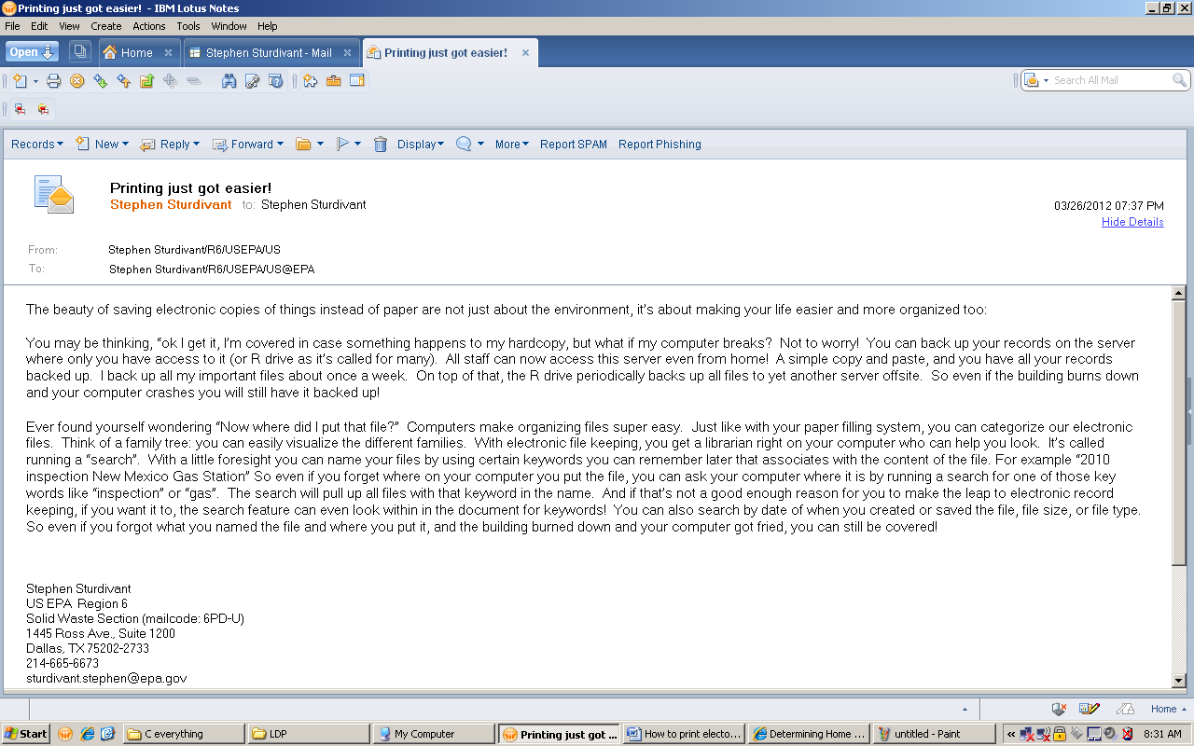

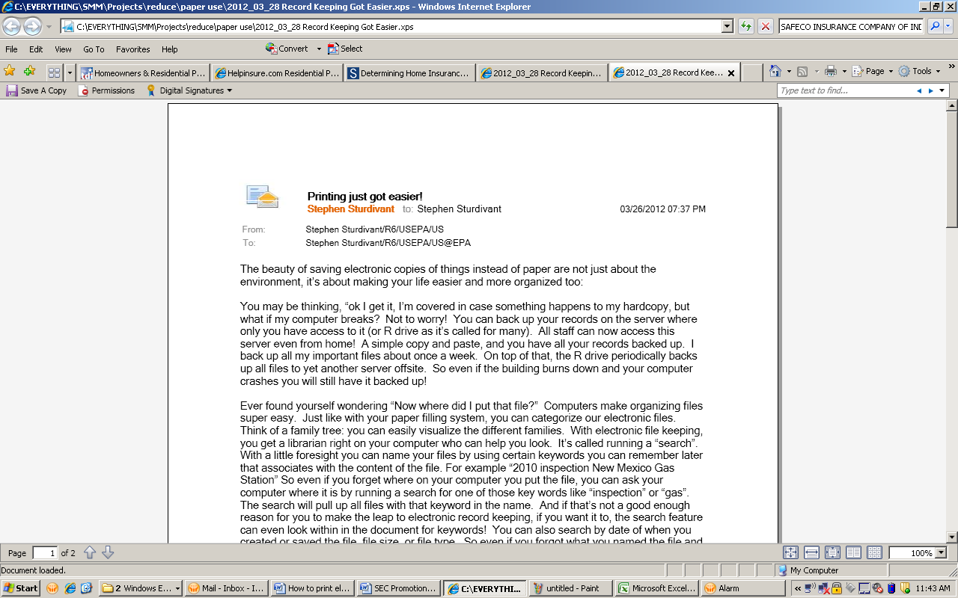
Into this:

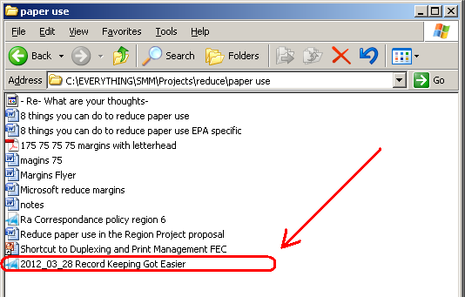

… a file you can put anywhere on your computer:

It’s super easy. This “virtual printer” is already an option in your pull down menu when you go to print. One option is to look for “Microsoft XPS Document Writer” (“Adobe” is better if you have it):
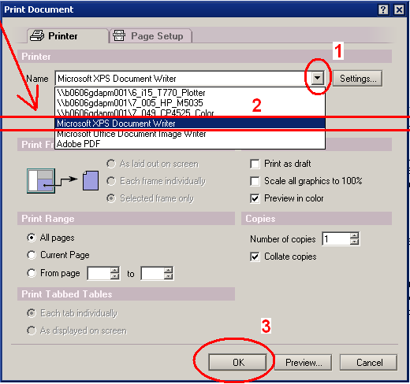
Note: Be sure to keep the file extension (.xps) when you rename the file.
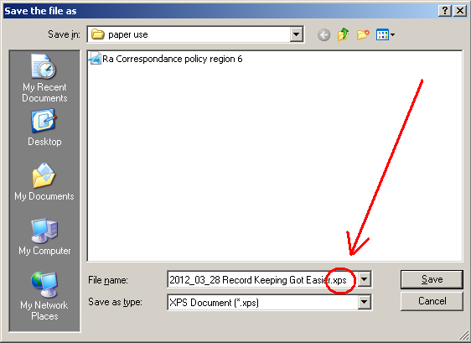
Open the file to make sure it captured your document correctly.
Enjoy!

