How to Print Confidential Documents Using a Password

- With the document that you wish to print open, follow the normal procedures for printing a document. You should see the following dialog box.

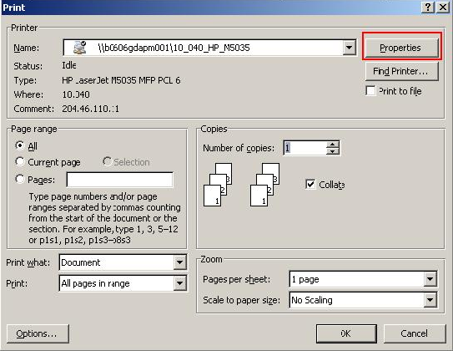
- Click the properties button.

- After clicking properties, the following dialog box will appear.

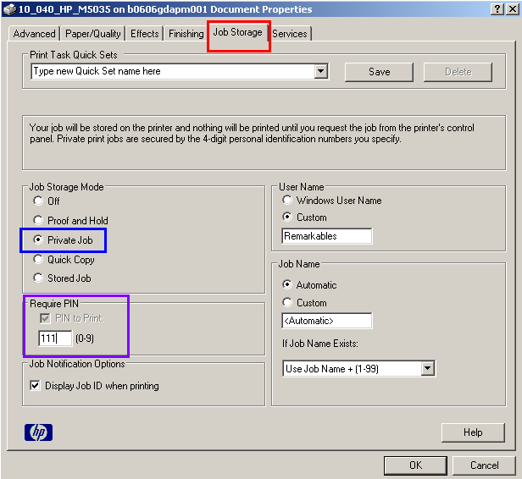
- Click on the Job Storage Tab.

- Select Private Job under Job Storage Mode.

- Enter a number in the require PIN box.

- Press OK. This returns you to the original dialogue box. Press OK again.

- If File name is shown press OK till printing starts.

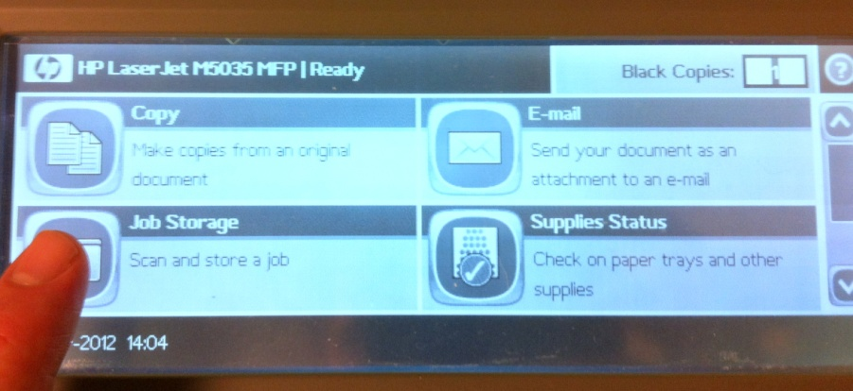
Go to printer and press the Job Storage button

- After clicking Job Storage, the following dialog box will appear. Select the appropriate folder and file from the drop down list.

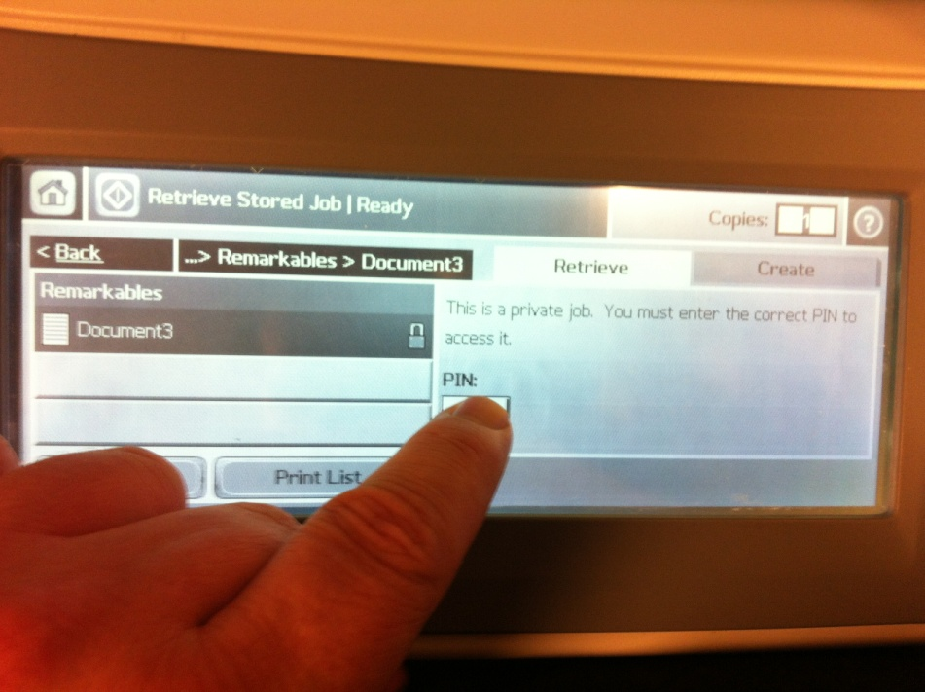
Select the correct folder then select the correct file. A PIN box will appear.

Press the PIN box.

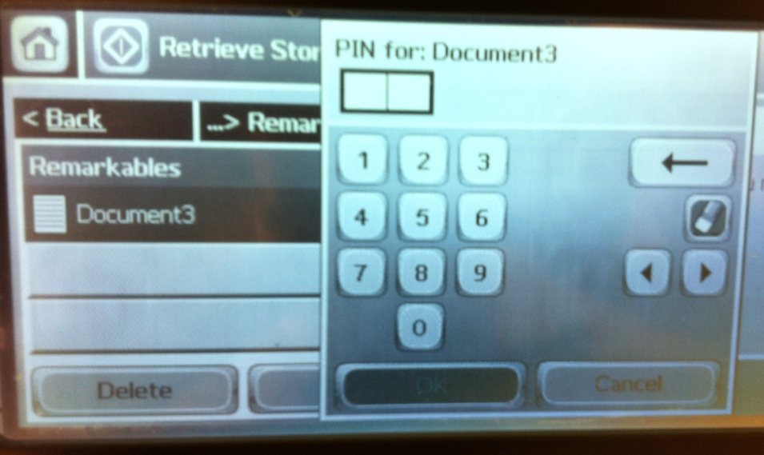
Type in the PIN using the pop up keypad.

Press OK.

- Press the green “Start” button atop the printer to print.

